

**Assignment No: 1**

***Subject: PROGRAMING FUNDAMENTAL***

***Topic: C LANGUAGE***

***Submitted by: Syed Shaheer Ali Shah***

***Reg No: FA20-BCS-079***

***Submitted to: Sir Ali Iqbal***

***Deadline: March 27, 2020.***

**Question no 1:** Write a program that takes any ASCII value from user and display next five char after that ASCII value.

**Code:**

#include<stdio.h>

int main()

{

int i=0;

char a;

printf("Enter a variable to print their next 5 variables\n");

scanf("%c",&a);

printf("Next 5 variable are given below\n");

while(i<5)

{

a++;

printf("%c\t",a);

i++;

}

return 0;

}

**Dry run:**

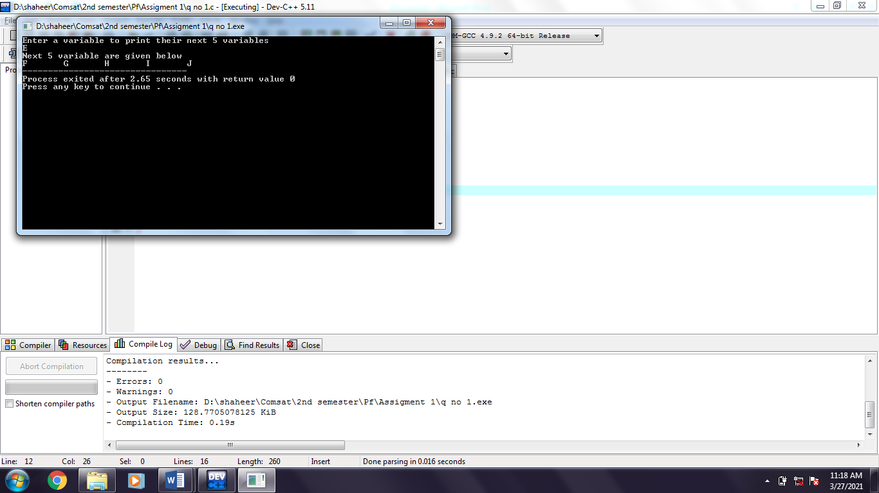

**Question no 2:** Write a program that reads a four-digit number from user, then the program separates digits of the number.

**Code:**

#include<stdio.h>

int main()

{

int x,a,b,c,d;

printf("Enter a 4 digit number\n");

scanf("%d",&x);

a=x%10;

x=x/10;

b=x%10;

x=x/10;

c=x%10;

x=x/10;

d=x;

printf("Digits are %d\t%d\t%d\t%d\t",d,c,b,a);

return 0;

}

**Dry Run:**

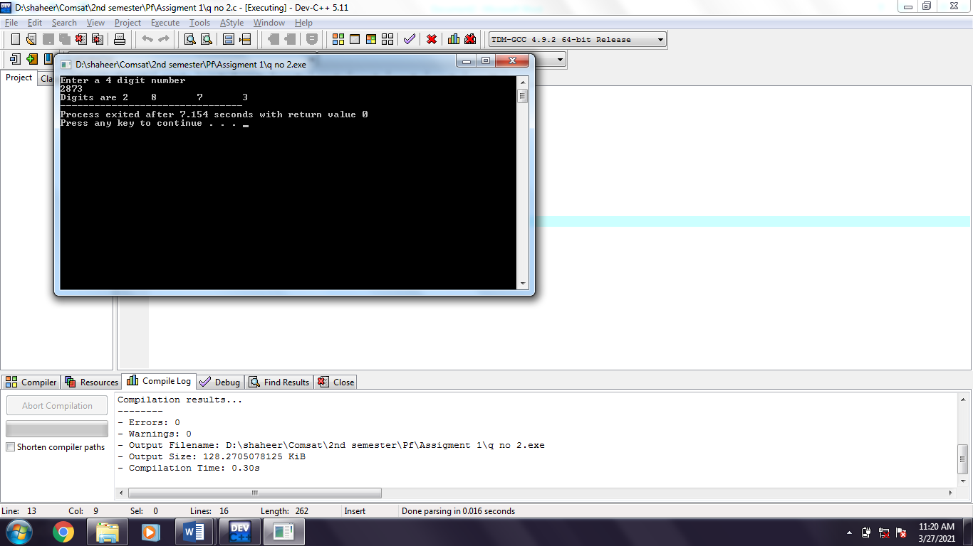

**Question no 3:** Write a program that finds the area of a triangle given the length of its sides: a, b, c.

**Code:**

#include<stdio.h>

#include<math.h>

int main()

{

float a,b,c,d,s;

float area;

printf("Enter three side of triangle\n");

scanf("%f%f%f",&a,&b,&c);

s=(a+b+c)/2;

d=(s)*(s-a)*(s-b)*(s-c);

area=sqrt(d);

printf("Area of triangle is %f",area);

return 0;

}

**Dry run:**

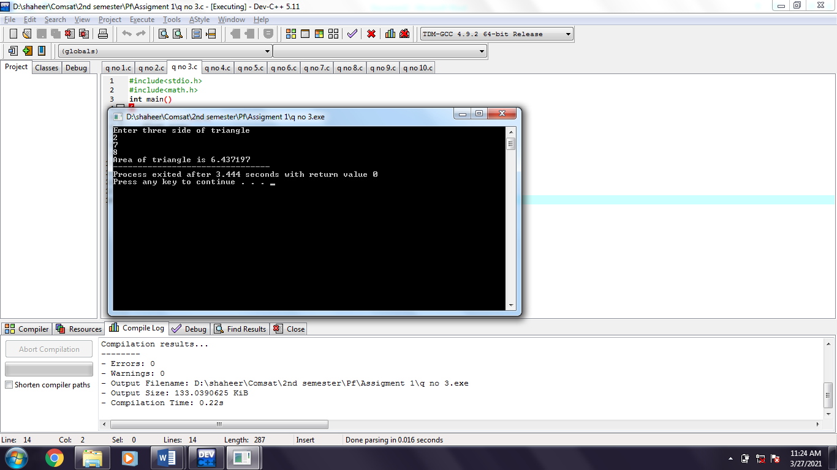

**Question no 4:** Write a program that inputs a 4-digit value from the user (for example 6382) and displays a result with an increment of 1 in each digit (i.e. 7493).

**Code:**

#include<stdio.h>

int main()

{

int x,a,b,c,d;

printf("Enter a 4 digit number to find increment in each\n");

scanf("%d",&x);

a=x%10;

x=x/10;

b=x%10;

x=x/10;

c=x%10;

x=x/10;

d=x;

a++;

b++;

c++;

d++;

printf("Icrement Digits are %d%d%d%d",d,c,b,a);

return 0;

}

**Dry Run:**

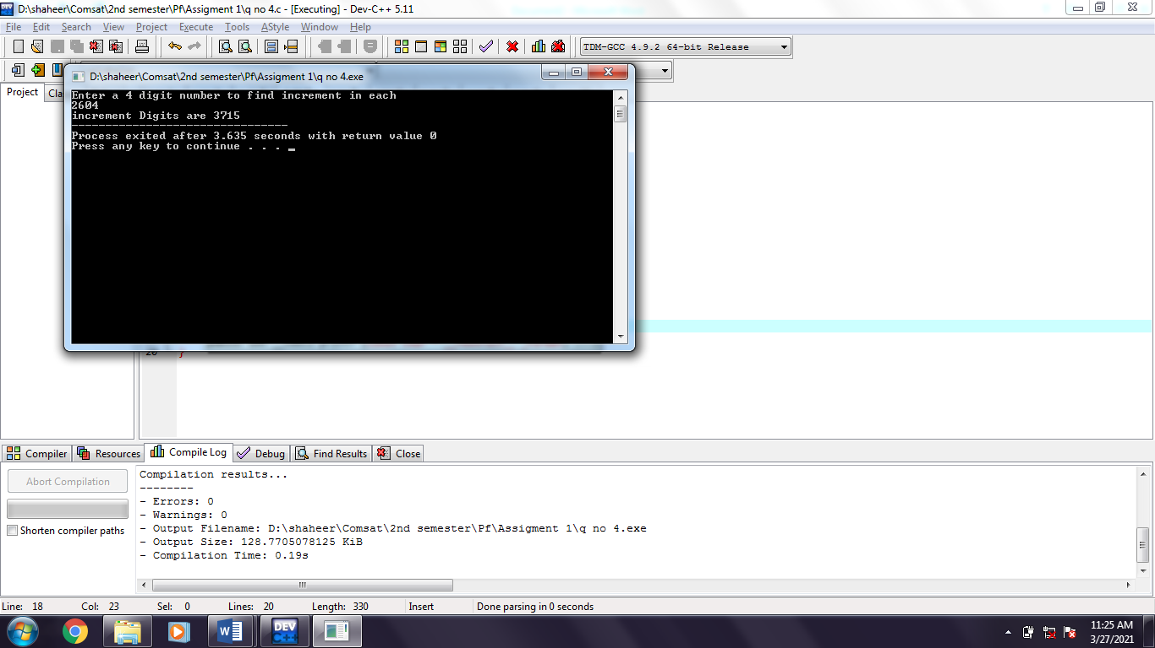

**Question no 5:** Write a program that takes any ASCII value from user and display next five char after that ASCII value.

**Code:**

#include<stdio.h>

int main()

{

int i=0;

char a;

printf("Enter a variable to print their next 5 variables\n");

scanf("%c",&a);

printf("Next 5 variable are given below\n");

while(i<5)

{

a++;

printf("%c\t",a);

i++;

}

return 0;

}

**Dry Run:**

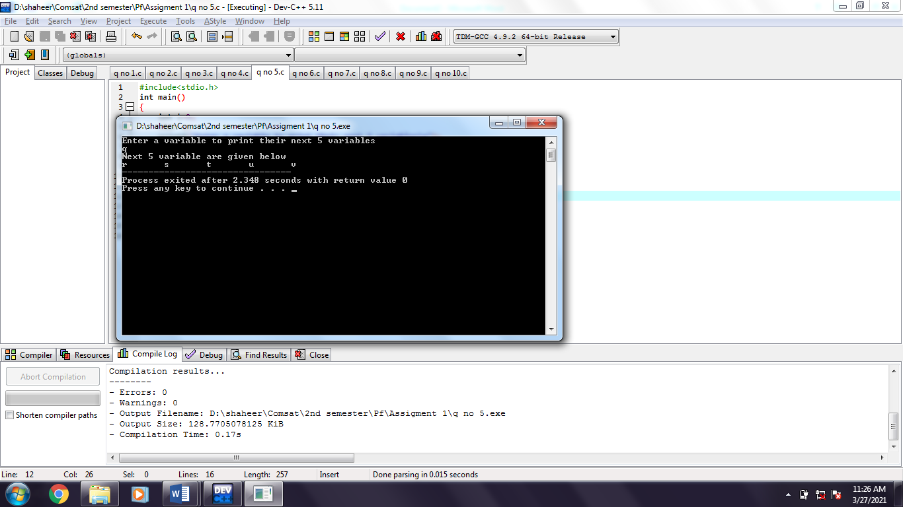

**Question no 6:** Write a program that reads a four-digit number from user, then the program separates digits of the number.

**Code:**

#include<stdio.h>

int main()

{

int x,a,b,c,d;

printf("Enter a 4 digit number\n");

scanf("%d",&x);

a=x%10;

x=x/10;

b=x%10;

x=x/10;

c=x%10;

x=x/10;

d=x;

printf("Digits are %d\t%d\t%d\t%d\t",d,c,b,a);

return 0;

**Dry Run:**

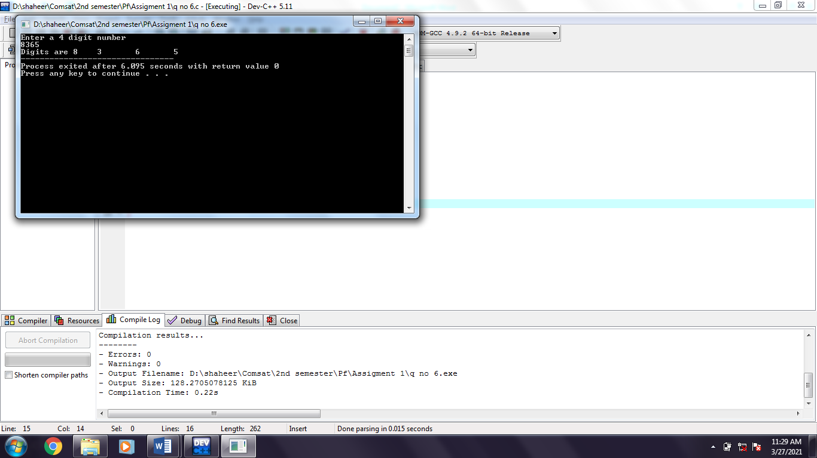

**Question no 7:** Input 5 values from the user and display the number of positives, the number of negatives and the number of zeros amongst the 5 values.

**Code:**

#include<stdio.h>

int main()

{

int a,c1=0,c2=0,c3=0,i=1;

printf("Enter 5 number\n");

while (i<=5)

{

scanf("%d",&a);

if(a==0)

{

c1++;

}

else if(a>=0)

{

c2++;

}

else

{

c3++;

}

i++;

}

printf("You eneter %d positive number %d zero and %d negative number",c2,c1,c3);

return 0;

}

**Dry Run:**

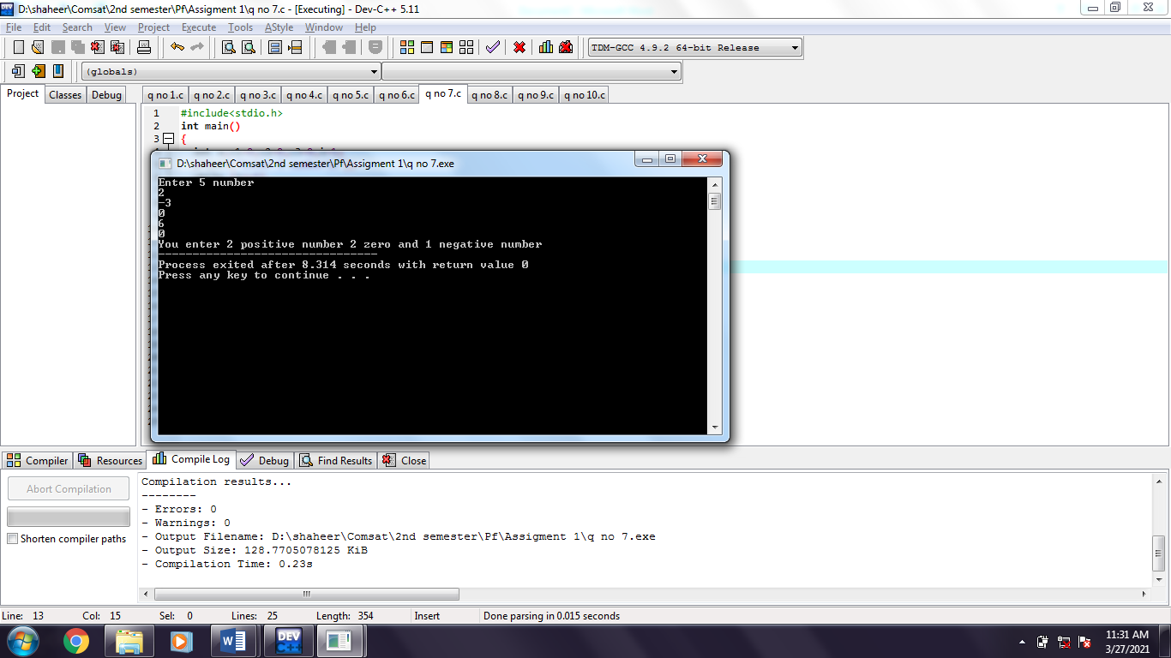

**Question no 8:** Prompt the user to input a character and display whether it is a vowel or constant using switch statement.

**Code:**

#include<stdio.h>

int main()

{

int a,low,up;

printf("Enter a charcter to check weather its is Vowel or constant\t");

scanf("%c",&a);

switch(a)

{

case 'a':

case'A':

case 'e':

case'E':

case 'i':

case'I':

case 'o':

case'O':

case 'u':

case'U':

printf("You entered a vowel word\n");

break;

default :

printf("You entered a constant word\n");

}

return 0;

}

**Dry Run:**

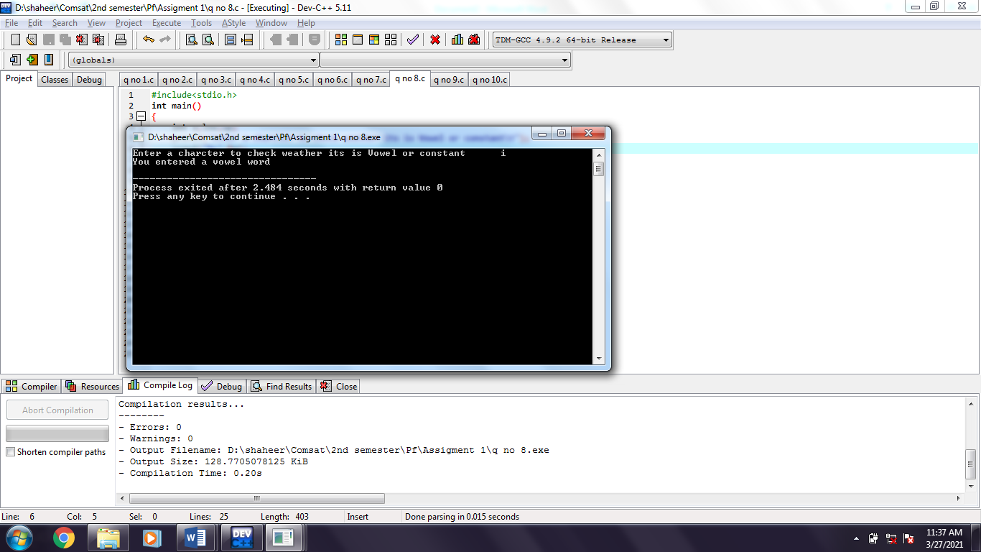

**Question no 9:** Ask the user to enter marks obtained in a course and the total marks of the course. Then display a menu

Press 1 to calculate percentage.

Press 2 to display grade.

If the user presses 1 then percentage should be displayed and if the user presses 2 the grade against the marks should be displayed. (Hint: use switch statement for menu selection and else if to display the grade).

**Code:**

#include<stdio.h>

int main()

{

int c;

float a,b,d;

printf("Enter obtained marks of a course\t");

scanf("%d",&a);

printf("Enter total marks of a course\t");

scanf("%d",&b);

ss:

printf("Press 1 to calculate percentage\nPress 2 to display grade\n");

scanf("%d",&c);

d=(a*100)/b;

switch(c)

{

case 1:

printf("You obtained %f percent",d);

break;

case 2:

if(d>=80)

{

printf("Your grade is A+");

}

else if(d>=70)

{

printf("Your grade is A");

}

else if(d>=60)

{

printf("Your grade is B");

}

else if(d>=50)

{

printf("Your grade is C");

}

else if(d>=40)

{

printf("Your grade is D");

}

else if(d>=33)

{

printf("Your grade is E");

}

else

{

printf("Your grade is F");

}

break;

default:

printf("Please enter 1 or 2 \n");

goto ss;

}

return 0;

}

**Dry Run:**

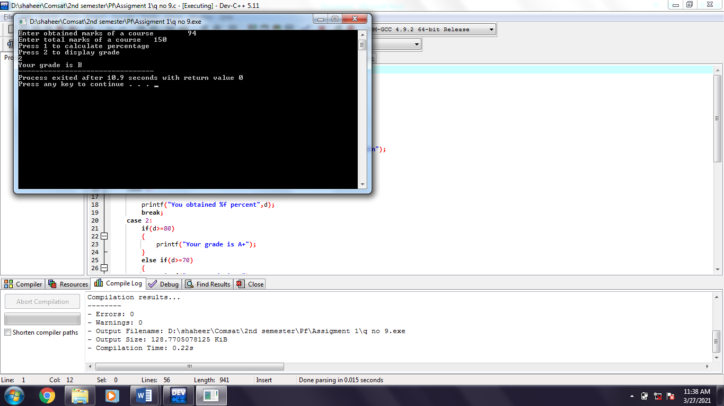

**Question no 10:** Prompt the user to enter 3 values. For any equal values, the program should display the numbers that are equal. (For example user input 34,6,34 the program should display the message that the 1st and 3rd values are equal).

**Code:**

#include<stdio.h>

int main()

{

int a,b,c;

printf("Enter three number\n");

scanf("%d %d %d",&a,&b,&c);

if(a==b)

{

printf("1st and 2nd value are equal");

}

else if(a==c)

{

printf("1st and 3rd value are equal");

}

else if(b==c)

{

printf("2nd and 3rd value are equal");

}

else

{

printf("No value are equal");

}

return 0;

}

**Dry Run:**

